Tokyo Marathon – International Travel Partner Program Application

KNT is designated by the Tokyo Marathon Foundation to operate International Travel Partner Program.
All applicants for the Tokyo Marathon International Travel Partner Program are required to complete this form and send it to tm-tours@or.knt.co.jp.

Company Information
Company name
Country
Address
Phone
Email
Website
Years in business
Number of employees
Tour operator license info
Primary contact person

Key Trading Points
What would be your ideal entry allocation?
How do you plan to market the Tokyo Marathon? Please briefly explain your channel and marketing strategy.
Does your company collaborate with any other AbbottWMM? If so, please specify.
Which travel elements will be included in your package?
Do you provide simple FIT package or organized group tour?

Thank you very much for completing the form.
Please understand that the entries are limited and we may not be able to grant your requests.
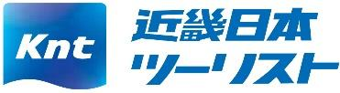
KNT is an official partner of Tokyo Marathon.

